***NAME: Soha Hanafy Saeed Marzouk***

***B.N: 398***

***TOPIC: Database Systems***

GitHub email:

<https://sohahanafy.github.io/ece001/>

GitHub pages: https://sohahanafy.github.io/ece001/

SOHA HANAFY

APPLICATION BRIEF:

You might not realize it, but databases are everywhere. Whether or not you know very much about them, their effect on our daily lives is extensive. From weather applications to the movies you watch online, databases are responsible for many of the services we utilize daily.

We have collected a few of the more well-known examples of how databases enhance your day-to-day life below. The most popular database server in our industry, MySQL, is prevalent in virtually every example listed below.

**1. Online Television Streaming**

Any online streaming service, such as Hulu or Netflix, uses databases to generate a list of TV shows and movies to watch. The database tracks an individual’s show preferences, and provide a list of recommended viewing.

The power required to analyze such an enormous amount of data is done through highly-specialized database management technology, such as Cassandra. In fact, Hulu has recently been relying heavily on Apache Cassandra.

**9. Healthcare**

Doctor’s offices and healthcare organizations, among others, store extensive amounts of patient data for easy accessibility. The databases behind this collection of information are large and complex and secure protected data. This is in compliance with HIPAA standards.

Healthcare.gov relies on a NoSQL database to manage their health insurance information. Cassandra is one such example of a NoSQL database software.

SCREENSHOTS

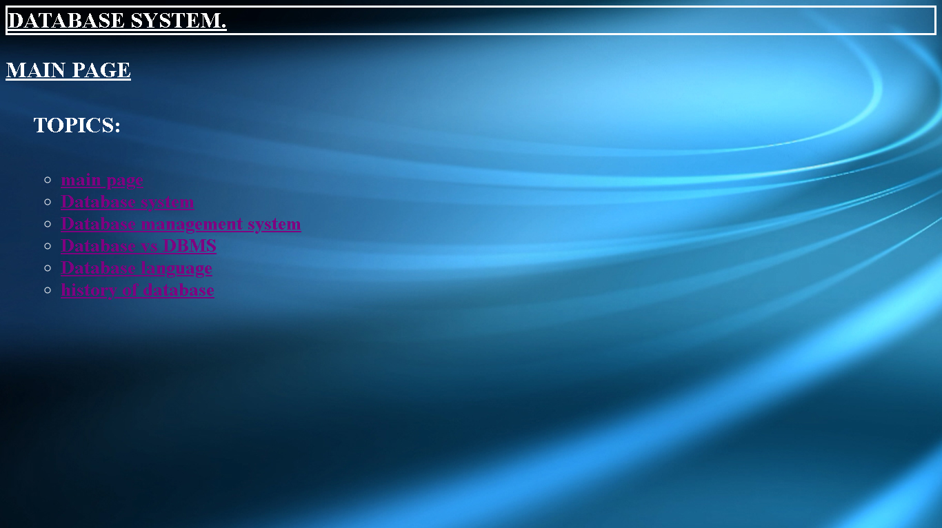

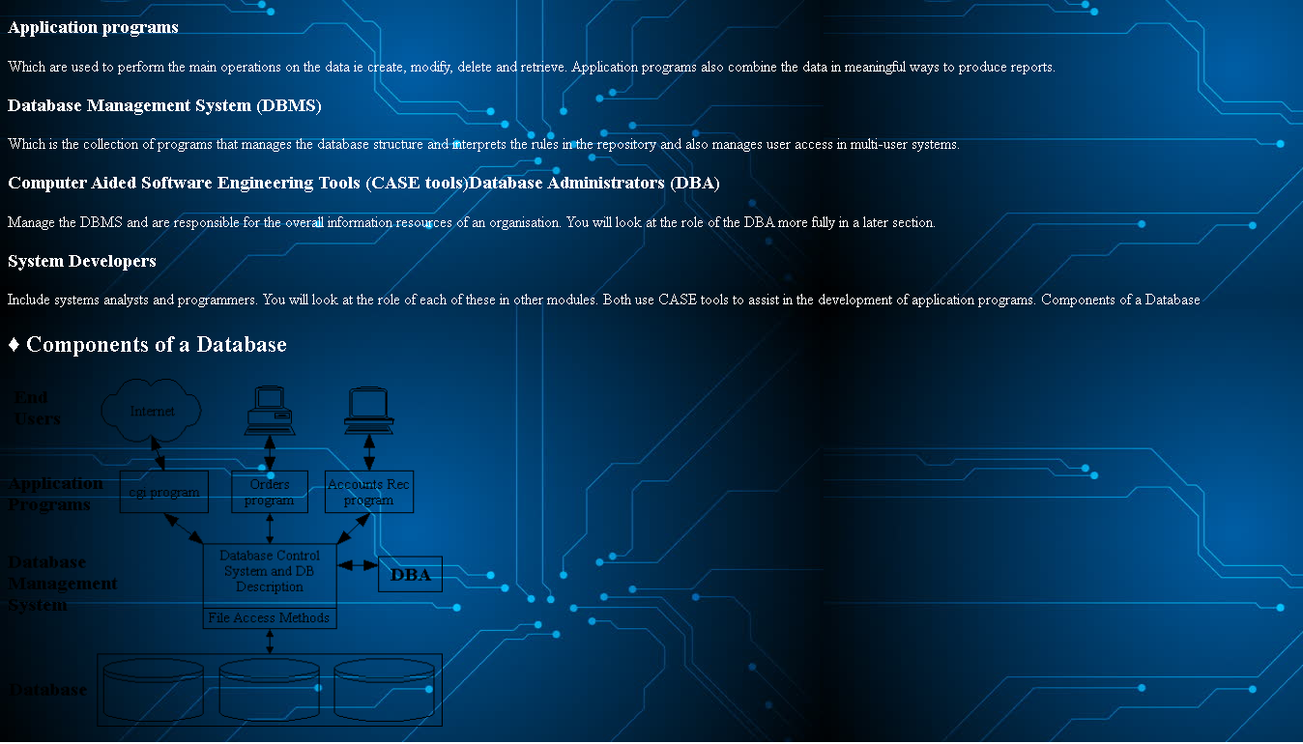

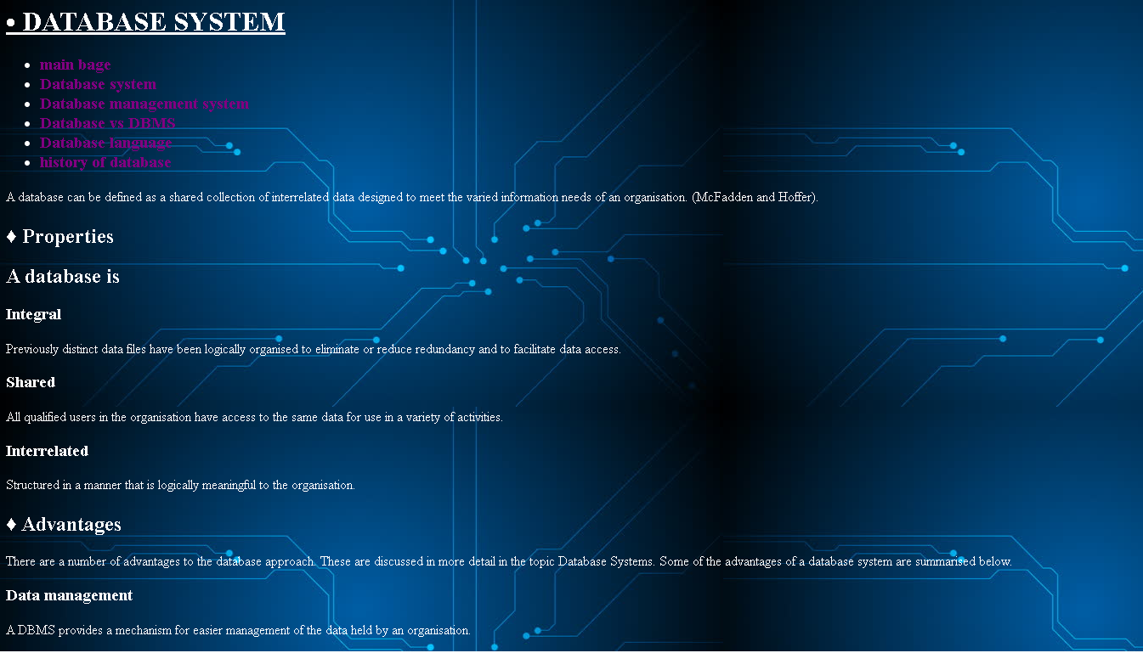

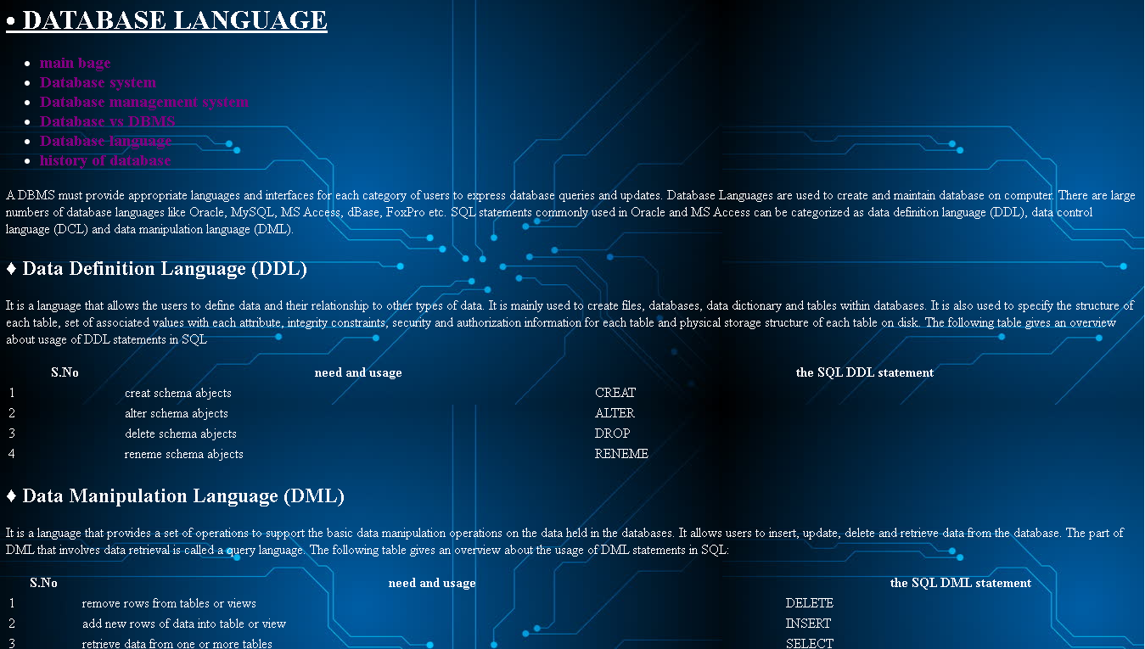

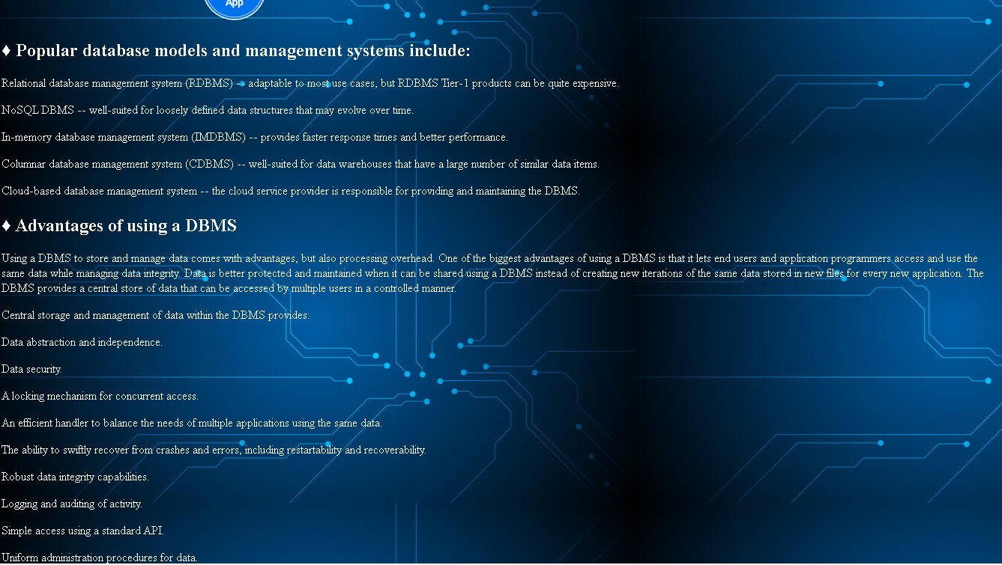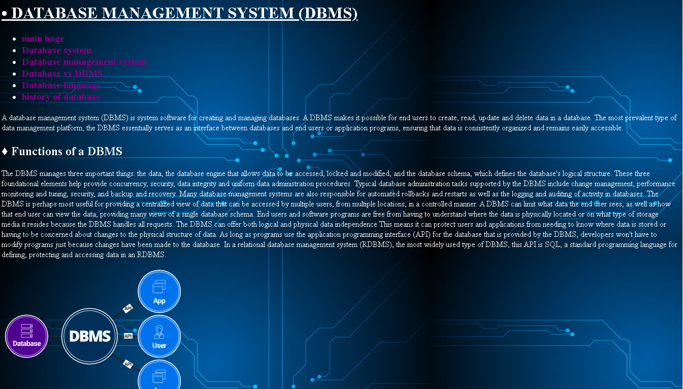

SOURCE CODE

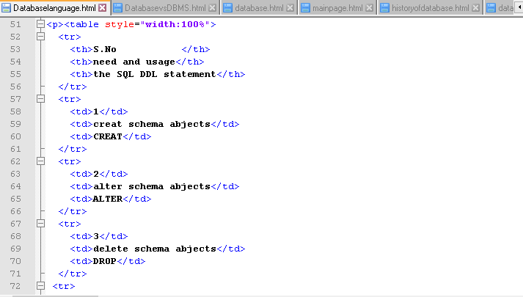

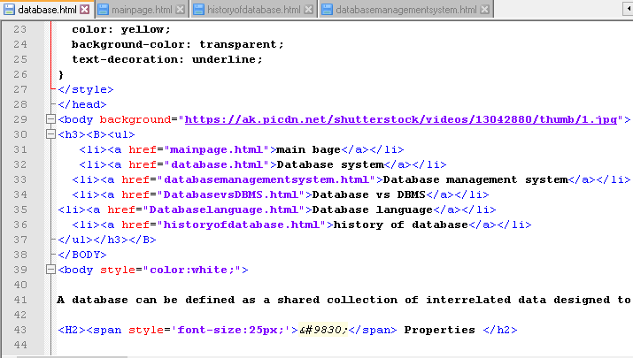

**REFERANCES**

* Beynon-Davies, Paul. *Database systems*. Basingstoke, UK: Palgrave Macmillan, 2004.
* Berg, Kristi L., Tom Seymour, and Richa Goel. "History of databases." *International Journal of Management & Information Systems (IJMIS)* 17, no. 1 (2013): 29-36.
* <https://sielearning.tafensw.edu.au/toolboxes/Database_Administration/content/dbsystems/definitions.htm>
* <https://searchsqlserver.techtarget.com/definition/database-management-system>
* <http://ecomputernotes.com/fundamental/what-is-a-database/database-languages>